Big Corporations
Student Name
Institution Affiliations
Date

How have big corporations changed the political, social/cultural, and economic landscape, and what are the consequences?
- Political
Texas is far sighting the country's major population collisions, and individuals moving there from different abundant nations may nourish political changes in that red-nation traditionalist. Ping and John Bauer were the big draws of Texan, and they are planning to make a move this year from orange region, California (Henderson, 2020). Texas has also been a bar magnet for doers lately due to the rising process of oil, which has advanced its economy. This is according to their labor economist Pia Orrenius of the federal reverse bank of Dallas. The political change occurred when young individuals moved to town areas inside the red nations, and later met new arrivals from other nations and new emigrant cultures.
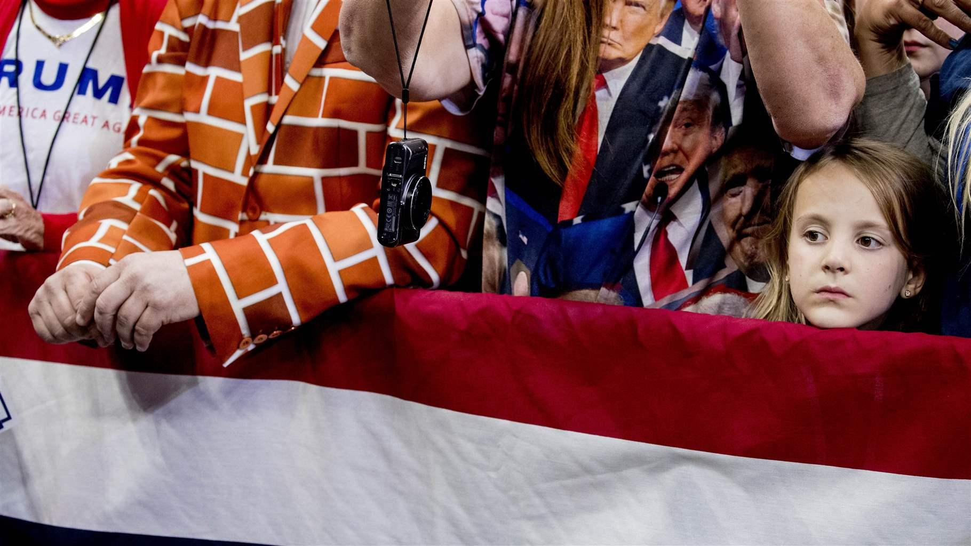
Image 1: Trump supporters at an October rally in Dallas. An influx of voters from blue states is making politics more unpredictable in Texas and other red states.
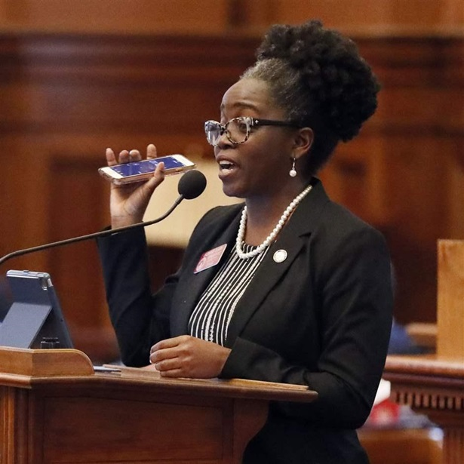
Image 2: Texas, south face political changes as movers arrive
- Social/cultural
Company values can be ambiguous to jot down and describe simultaneously, but for the furthermost portion, it's the corporation's inimitable behavior, opinions, insolence, and landscape. According to (Peterson et al. 2014), several things can impact our culture, and they comprise (1) Using influence to make things better. Most companies have leaders whom they expect not to act like bosses. Instead, these leaders lead by example that their employees need to follow and need to understand the company's vision to help others in supporting that vision. (2) Being open, transparent, and fair. In the office, there will be individuals who backbite their leaders regarding their position in the company, but instead of picking a fight as a leader, you need to change such behavior. As a leader, you need to be open, clear, and fair, and that way, employees will respond even if it will take time.
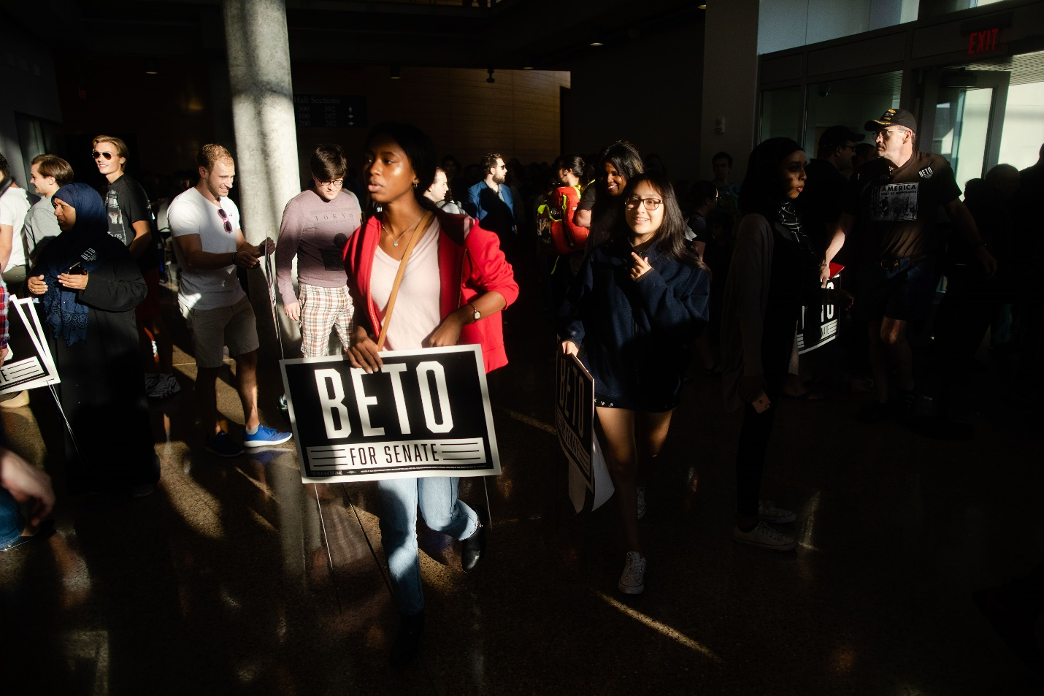
Image 3: Attendees depart an event with Rep. Beto O'Rourke at the University of Texas at Dallas
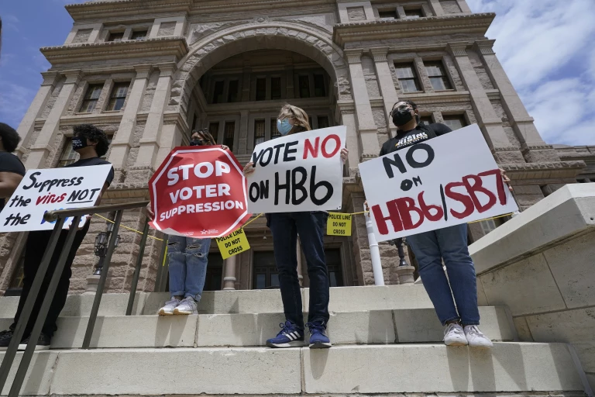
Image 4: Opponents to Texas voting bills demonstrate at the state Capitol in Austin.
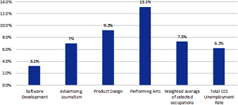
Image 5: Unemployment Rate in the Cultural and Creative Sectors in Germany, Selected Occupations, June 2020
- Economic
Texas has exclusive environmental and demographic significances that have assisted boost its economy in existing centuries (MCNICHOL et al., 2012). The boundary site inspires trade and arrival and assists oil residents and job development. The Texas advance accounts are famous by now. In 1980- 2011, Texas population grew by 12 million individuals, approximately 80 percent double the growth rate of the whole nation.
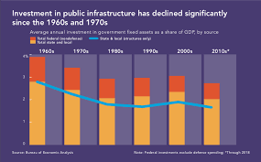
Image 6: Public Infrastructure Investment Faces Challenges

Reference
Henderson, T. (2020). Texas, South Face Political Changes as Movers Arrive. Accessed online at. https://www.pewtrusts.org/en/research-and-analysis/blogs/stateline/2020/01/13/texas-south-face-political-changes-as-movers-arrive
McNichol, E., & Johnson, N. (2012). The Texas economic model: Hard for other states to follow and not all it seems. Center on Budget and Policy Priorities, 1-11.
Peterson, B. CEO, C0-FOUNDER & Bamboo. (2014). 7 Ways you can Impact Company Culture. Accessed online at. https://www.inc.com/ben-peterson/7-ways-you-can-impact-company-culture.html
Videos
https://www.dallasfed.org/research/economics/2020/0924.aspx
https://spectrumlocalnews.com/tx/austin/news/2020/10/29/independent-voters-could-impact-election-in-texas
Pictorials
Image 1.
https://www.pewtrusts.org/en/research-and-analysis/blogs/stateline/2020/01/13/texas-south-face-political-changes-as-movers-arrive
Image 2.
https://www.pewtrusts.org/-/media/post-launch-images/2020/01/sln_jan13_1/16x9_m.jpg?mw=910&hash=37849BEB3D970591B5DF5989931E722D
Image 3.
https://media.beam.usnews.com/1e/a1/6c999df34dd9b3f58de86eb5df52/181011bstexas-editorial.texas.jpg
Image 4.
https://www.latimes.com/politics/story/2021-05-06/texas-voting-restrictions-republicans-business
Image 5.
https://www.oecd.org/coronavirus/policy-responses/culture-shock-covid-19-and-the-cultural-and-creative-sectors-08da9e0e/images/images/08da9e0e/media/image8.png
Image 6.
https://www.ced.org/images/uploads/infrastructure-fig1.png

B.) Texas governor Greg Abbott signed many controversial bills into law this passed legislative session. Research a law that was passed and tell us what you think about this law. Do you think that it will be beneficial to the people of Texas? Why or why not? Explain why and who supported the law and who opposed it. What will the long term effects of this law be? Write a 300-word post and respond to 2 other people for full credit. Make sure to cite your sources.Â
https://legiscan.com/TX/legislation/2021Â

Gregory Abbott is a Republican politician serving as the governor of the State of Texas. In this session, governor Abbott has signed more than a thousand bills. One of the bills vetoed by Greg Abbott was Senate Bill 69, passed on May 25 2021 which banned the police officers in Texas from the utilization of Chokeholds during the arrest of lawbreakers. That is, it prevented the police from applying pressure on the throat of the offender, their torso, or the neck in ways that would tamper. This law would be beneficial to the people of Texas since it would permit police officers to stop another police officer if they thought that their partner was using unnecessary force to apprehend a person suspected of committing an offense. Moreover, it would ensure that offenders and suspects do not suffer any physical, mental, and psychological injuries or death under police custody.
The bill was supported by Senator Boris Miles, Houston Senator who claimed that his support was due to the response in statistics that showed that at least a hundred and thirty people nationwide had died in the custody of the police due to different asphyxiation in the past ten years, including the death of George Floyd. Moreover, many cases of police brutality towards the citizens are not usually documented therefore, the police don’t usually face the law. According to the different police departments, the police used a controlled number of restraints to control the crowds during protests and offenders. The bill was passed at 31-0 votes.
The passing of this bill would ensure that police brutality is reduced, and police accountability is increased. it ensures that the citizens and the police department act in a manner that ensures integrity in their routine operations. Occasionally, police officers lack the integrity that ensures that citizens and law enforcement trust them.

Reference.
Texas Legislature website: https://capitol.texas.gov/BillLookup/History.aspx?LegSess=87R&Bill=SB69

